Class 1 (R/Y1/Y2)
Autumn 2

Working Wall:
Pathways Feature Keys R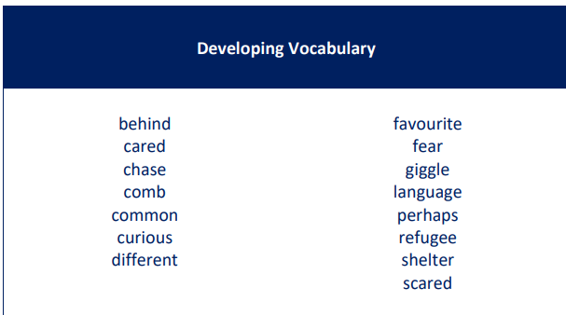 1/2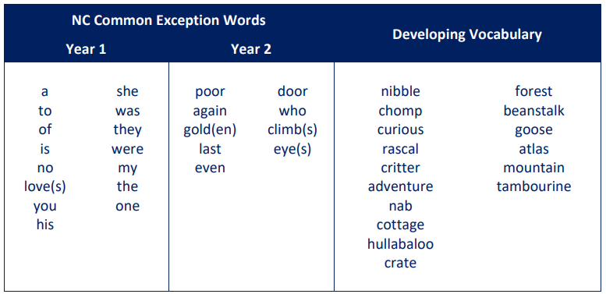

Key knowledge for foundation subjects

 | Week 1 | Week 2 | Week 3 | Week 4 | Week 5 | Week 6 | Week 7
English  Pathways to Write  Reception  Key Stage 1 | Bonfire Night  Make phonetically plausible attempts at words (ELG 10). Add some marks to their drawings, which they give meaning to. For example: “That says mummy.” Enjoy drawing freely. Make marks on their picture to stand for their name. Use some of their print and letter knowledge in their early writing. For example: writing a pretend shopping list that starts at the top of the page, write ‘m’ for mummy. Write some or all of their name. Write some letters accurately | Someone Just Like You by Helen Docherty #1, 2, 3  ASSESS  Understand the five key concepts about print: - the names of the different parts of a book. Use a wider range of vocabulary. Can start a conversation with an adult or a friend. Engage in storytimes. Listen to and talk about stories to build familiarity and understanding. Spell words by identifying the sounds and then writing the sound with letter/s. Use longer sentences of four to six words. Blend sounds into words, so that they can read short words made up of known letter-sound correspondences. | Someone Just Like You by Helen Docherty #4,5,6  Use a wider range of vocabulary. Form lower-case letters correctly. Re-read what they have written to check that it makes sense | Someone Just Like You by Helen Docherty #7,8,9 | Someone Just Like You by Helen Docherty #10,11,12 | Someone Just Like You by Helen Docherty #13, 14, 15  ASSESS | Christmas  -card
English  Pathways to Write  Reception  Key Stage 1 | Bonfire Night  1. Make phonetically plausible attempts at words (ELG 10). Compose a sentence orally before writing it. Combine words to make sentences. Use capital letters for names of people and the personal pronoun ‘I’. Leave spaces between words. Begin to use capital letters and full stops.  2. Use subordination (because) and coordination (and). Use expanded noun phrases to describe and specify. Use punctuation correctly-full stops, capital letters. | Nibbles the Book Monster by Emma Yarlett #1, 2, 3  ASSESS  1. Join words using and. Punctuate sentences using a capital letter and a full stop. Use capital letters for names of people  2.Use co-ordination (but, or) | Nibbles the Book Monster by Emma Yarlett  #4, 5, 6  1. Sequence sentences to form short narratives (link ideas or event by pronoun). Use plural noun suffixes –s and - es  2. Add -ly to turn adjectives into adverbs. Use commas to separate items in a list. | Nibbles the Book Monster by Emma Yarlett  #7, 8, 9 | Nibbles the Book Monster by Emma Yarlett  #10, 11, 12 | Nibbles the Book Monster by Emma Yarlett # 13, 14. 15  ASSESS | Revision of Gateway Keys  Christmas  -Letter to Santa
Phonics | Monster Phonics ASSESS | Monster Phonics week 7 | Monster Phonics week 8 | Monster Phonics week 9 | Monster Phonics week 10 | Monster Phonics week 11 | REVIEW/ASSESS
Phonics | Keep up/Catch up ongoing
Maths  White Rose | R Numbers to 5, Geometry (shape)  Y1 Addition & Subtraction within 10, Geometry (shape)  Y2 Addition & Subtraction, Geometry (shape) |  |  |  |  | REVIEW/ASSESS | Christmas
Science | R. Investigating materials.  ½ Everyday Materials:  Naming Materials | R. Investigating Materials  ½ Everyday Materials:  Material Detectives | R. I am a scientist  Push or Pull  ½ Everyday Materials:  Introduction to Properties | R. I am a scientist  Loud or Quiet  ½ Everyday Materials:  Is it absorbent? | R. I am a scientist  Float or Sink  ½ Everyday Materials:  Is it waterproof? | R. I am a scientist  Freeze or Melt  ½ Everyday Materials:  Is it tough? | R. I am a scientist  Light or Dark  ½ Everyday Materials:  Assessment
History  R. Peek in the past  1/2. How am I making history? | Remembrance Day | R. Can you guess who?  1/2. What is my history? | R. Past and Present  1/2. How can I find out more about myself? | R. My life timeline.  1/2. How are special events remembered? | R. Toy box  1/2. What was it like for children in the past? | R. Spot the Difference  1/2. What have I learned about childhood in the past? | 1/2. How am I making history?
Religious Education | Year A: Believing  R. F1 Which stories are special and why?  ½ 1.2 Who is Muslim and what do they believe?  Recap on Christianity | Year A: Believing  R. F1 Which stories are special and why?  ½ 1.2 Who is Muslim and what do they believe? | Year A: Believing  R.F1 Which stories are special and why?  ½ Who is Muslim and what do they believe? | Year A: Believing  R. F2 Which people are special and why?  ½ 1.4 What can we learn from sacred books? | Year A: Believing  R. F2 Which people are special and why?  ½ What can we learn from sacred books? | Year A: Believing  R. F2 Which people are special and why?  ½ What can we learn from sacred books?  The Christmas story | The Christmas Story (R & ½)
PSHE  (Inc. British Values)  Reception  activities dependent on books available  YR Objectives:  Seeing themselves as valuable individuals, expressing feelings and considering the feelings of others; showing resilience and perseverance in the face of challenge.  KS1 Objectives:  Recognising different groups they belong to; Identifying that everyone has different strengths; Recognising the ways in which they are the same/different; Recognising what makes them special; Identifying what makes us unique; Identifying what they are good at, what they like/dislike. | Being Me:  YR  Story discussion (one of set texts) /Role Play/Game/Art  KS1  What makes me, me? | Being Me  YR  Story discussion (one of set texts) /Role Play/Game/Art  KS1  Magic Box | Being Me  YR  Story discussion (one of set texts) /Role Play/Game/Art  KS1  Amazing Facts | Being Me  YR  Story discussion (one of set texts) /Role Play/Game/Art  KS1  ‘The Name Jar’ story. | Being Me  YR  Story discussion (one of set texts) /Role Play/Game/Art  KS1  Stepping Stones to Happiness | Being Me  YR  Story discussion (one of set texts) /Role Play/Game/Art  KS1  Taking Flight (Film clip) | Christmas activities  KS1  Community Walk or Christmas activities.  Assessment
Music | R & KS1: Tempo  Snail & Mouse | R & KS1: Tempo  Exploring Rhyme with Snail & Mouse | R & KS1: Tempo  Singing Snail & Mouse | R & KS1: Tempo  Performing Snail & Mouse | R & KS1: Tempo  The Story of Snail & Mouse | Christmas songs | Christmas songs
Computing | Creating Media: Digital Painting & Photography
PE  Circuit Training | Mind the Cones | Just Jump! | Balancing Act | Roll it, Bounce it | The Whole Circuit | Help your Partner
History
Art | Autumn nature wreaths |  |  |  |  | Landscape Collage (Megan Coyle) | Christmas
Design & Technology  R. Junk Modelling  1/2. Mechanisms |  | R. Exploring Junk Modelling  1/2. Exploring sliders | R. Cutting & Scissor Skill  1/2. Design | R. Choosing Resources  1/2. Construction | R. Making Models  1/2. Evaluation
Outdoor Learning | Collect materials for above | Forest School (reflection) | Hibernation | Painting (Kapow)

