School Parliament
We held an election at school to decide who should represent the children in our School Parliament. Each candidate presented their ideas and thoughts to the whole school and then everyone got to vote for who they thought would best represent their needs.
Below are some quotes from the children who presented their ideas:

Why do you want to be a member of our School Parliament?
“I think I’m very loyal and honest and always wanting to help others. I will use my free time to try to sort things out.”
“It will give me the opportunity to make fair choices for other people.”
“I understand everyone.”
“Because I love school.”
“I want to be helpful and help the school.”
“I think I make good choices.”
“It is a very important job and I can do a good job.”
“I’m in Y6 and I have good experience of how the whole school runs having been through each year group.”

Why do you think the children should vote for you?
“I will constantly be telling the teachers what we all want to do. I will be honest with everybody.”
“I will try and fit every one of your ideas into this School Parliament.”
“I’m organized and kind so I will listen to your opinions and try my best to resolve all situations where I can.”
“Because I’m a helper and I’m good at work.”
“I want to represent and make fair choices.”
“I have an impartial view on school topics meaning I can best represent all children.”
“Because I’m nice and kind.”
“I can help people and treat them kindly.”
“I’ll stick up for other children and help them out.”

What do you promise to do if you are elected?
“I will take your opinion to the meeting. I will be kind and caring and always willing to listen and help in all ways I can.”
“I will promise to listen to everyone’s ideas and I’d say that I’, kind and thoughtful.”
“I promise to put at least one idea in each playtime.”
“I promise to help them and be caring.”
“I will promise to listen to everyone.”
“I promise to be good at helping my friends.”
“I will promise to listen to everyone and take other people’s ideas instead of my own idea.”
“I promise to uphold school values and look out for the best interests of the other children, especially the younger ones. I promise to set an example to all the children and be a good role model.”
“Instead of having a boring old playground, how about a jungle gym? Just imagine what us kids will like outside.”

First the children presented their ideas to the whole school:
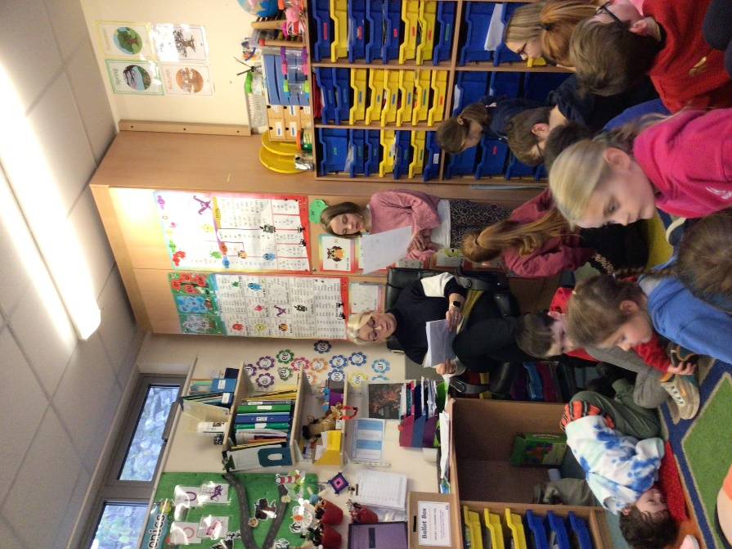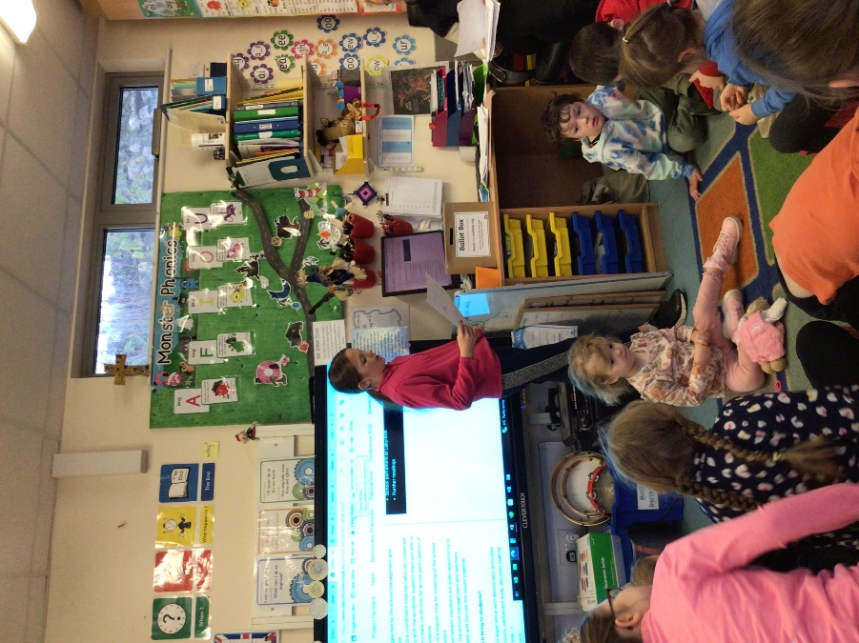
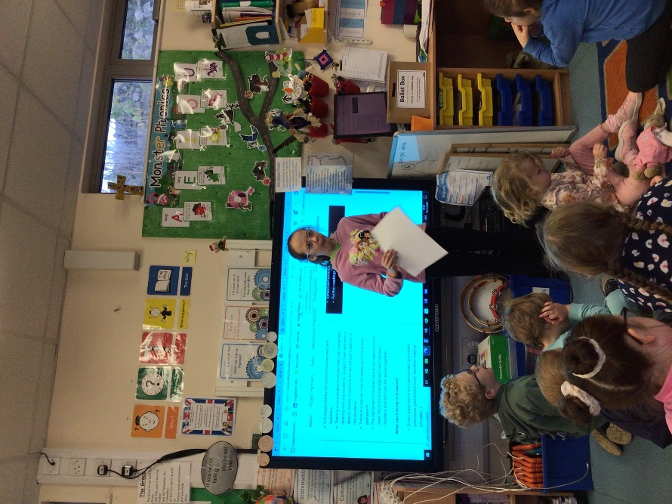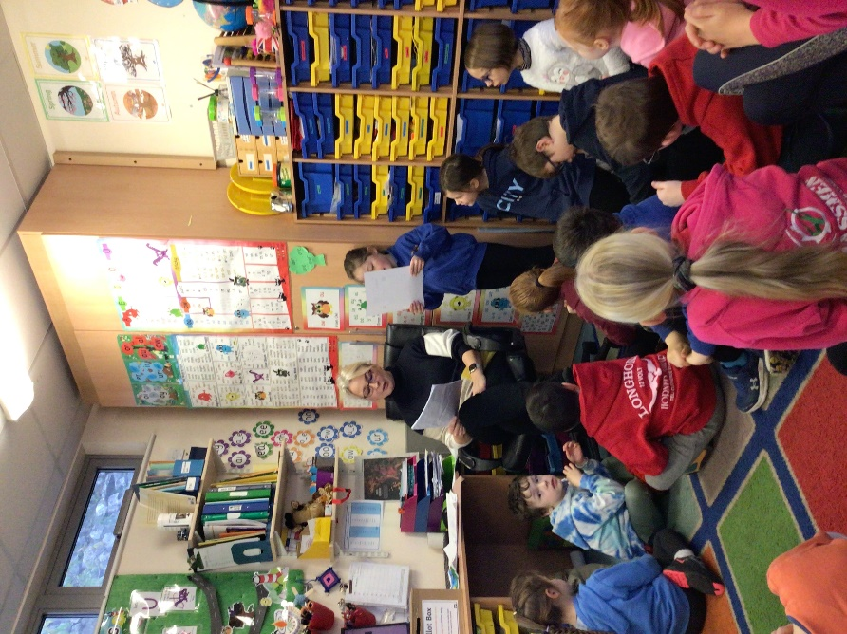
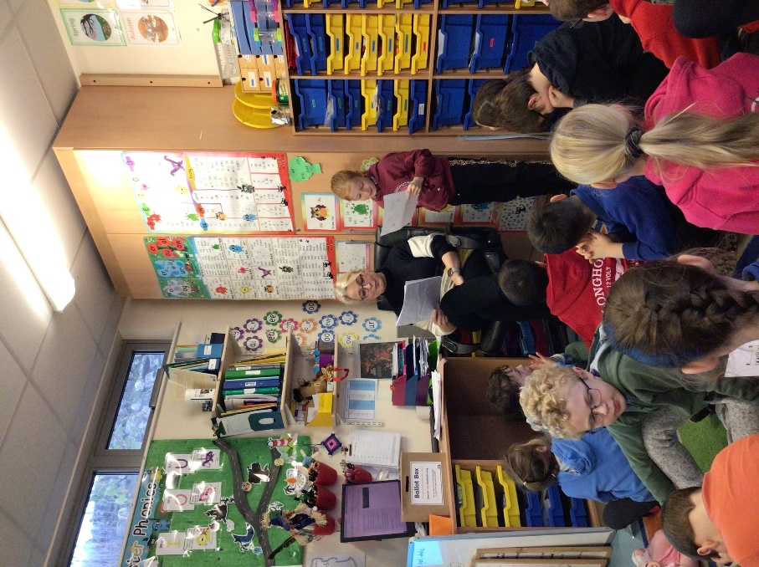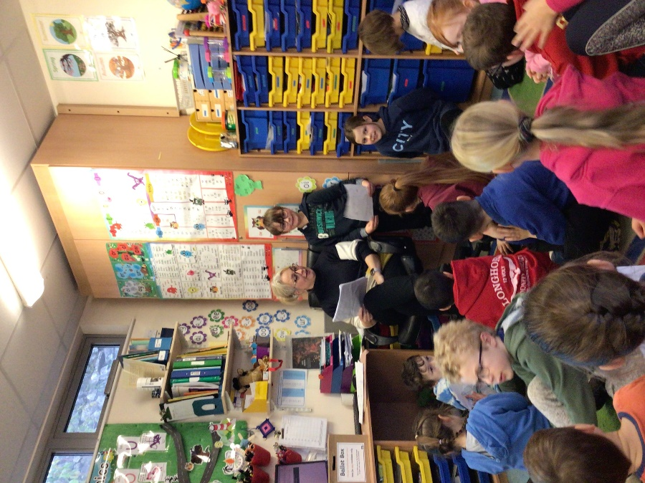
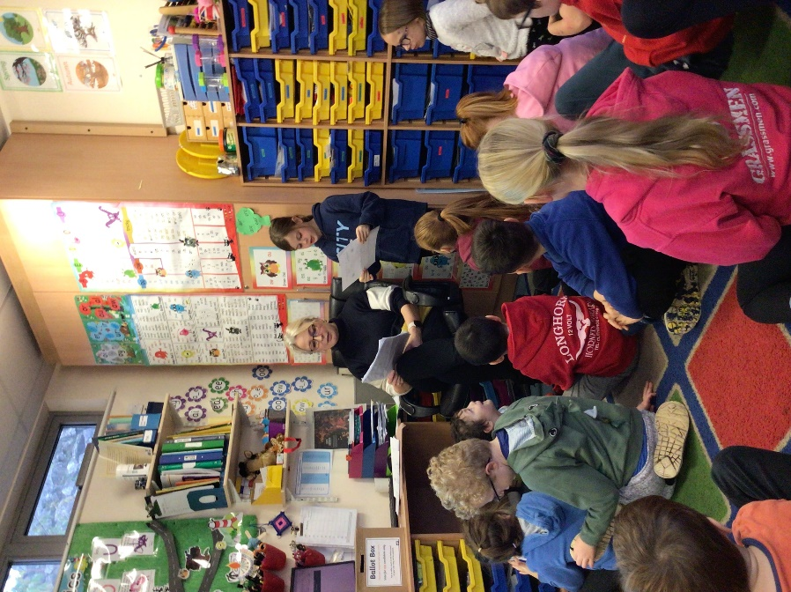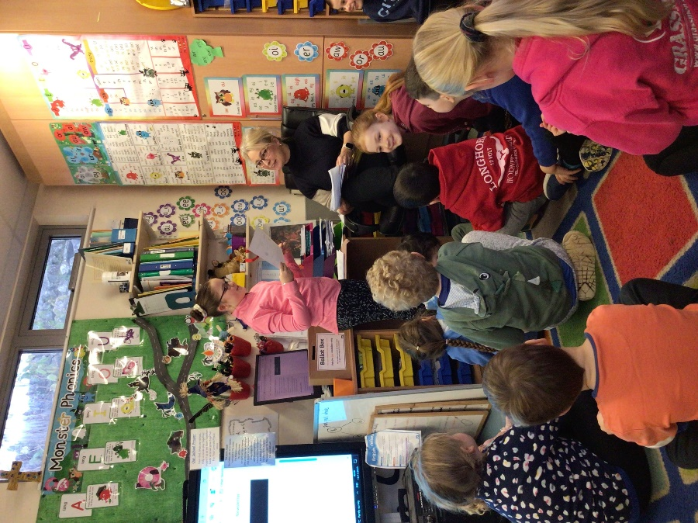
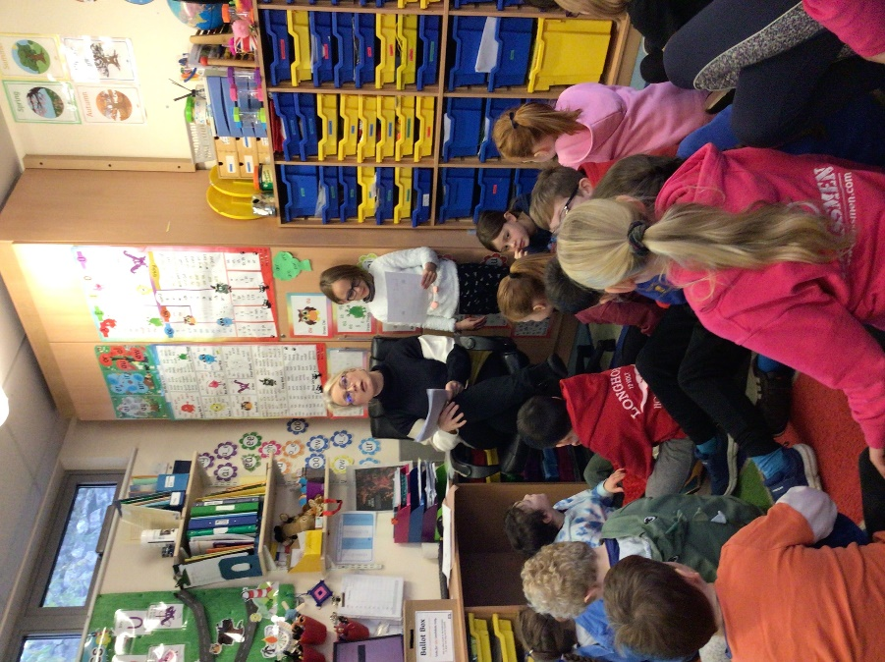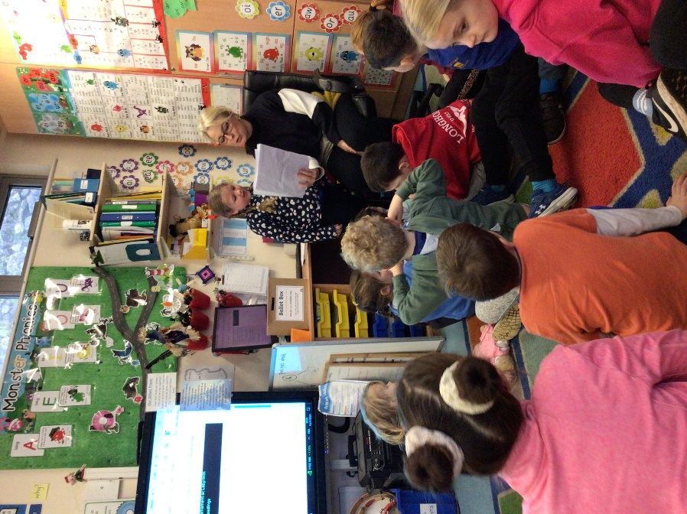

Then we voted and put our votes into the ballot box:
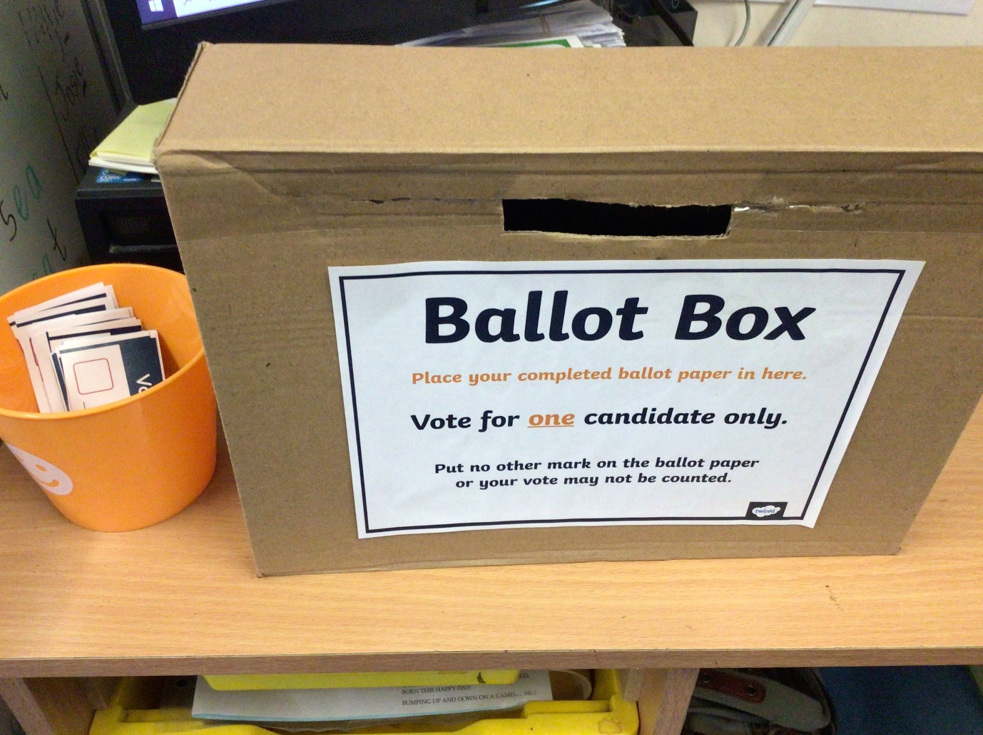
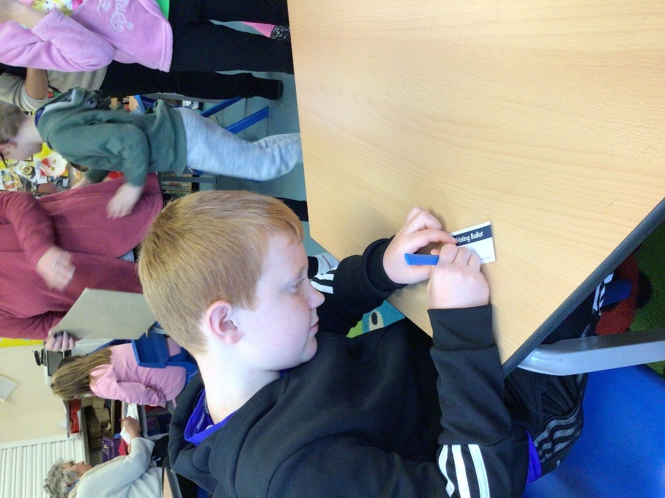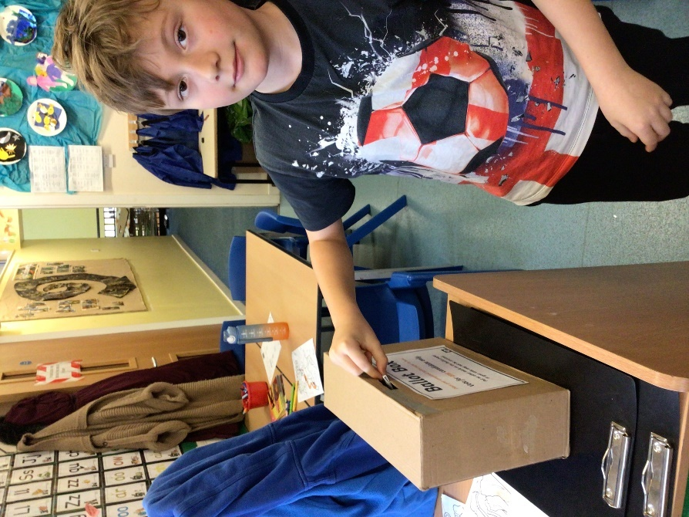
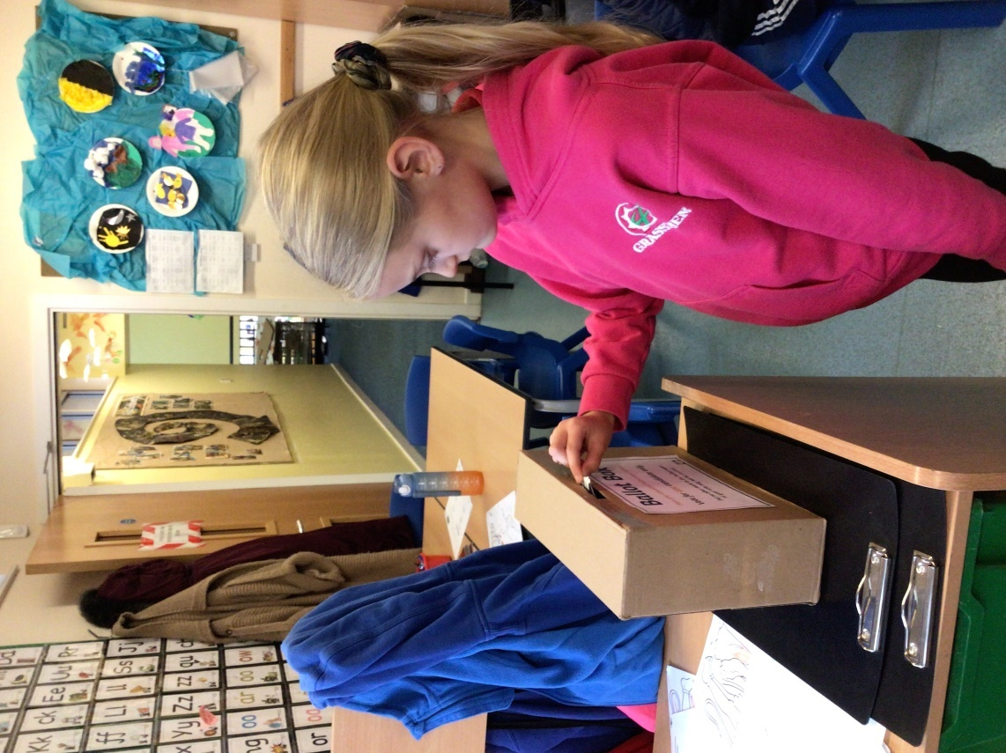
At dinner time our Chair of Governors announced the winners:
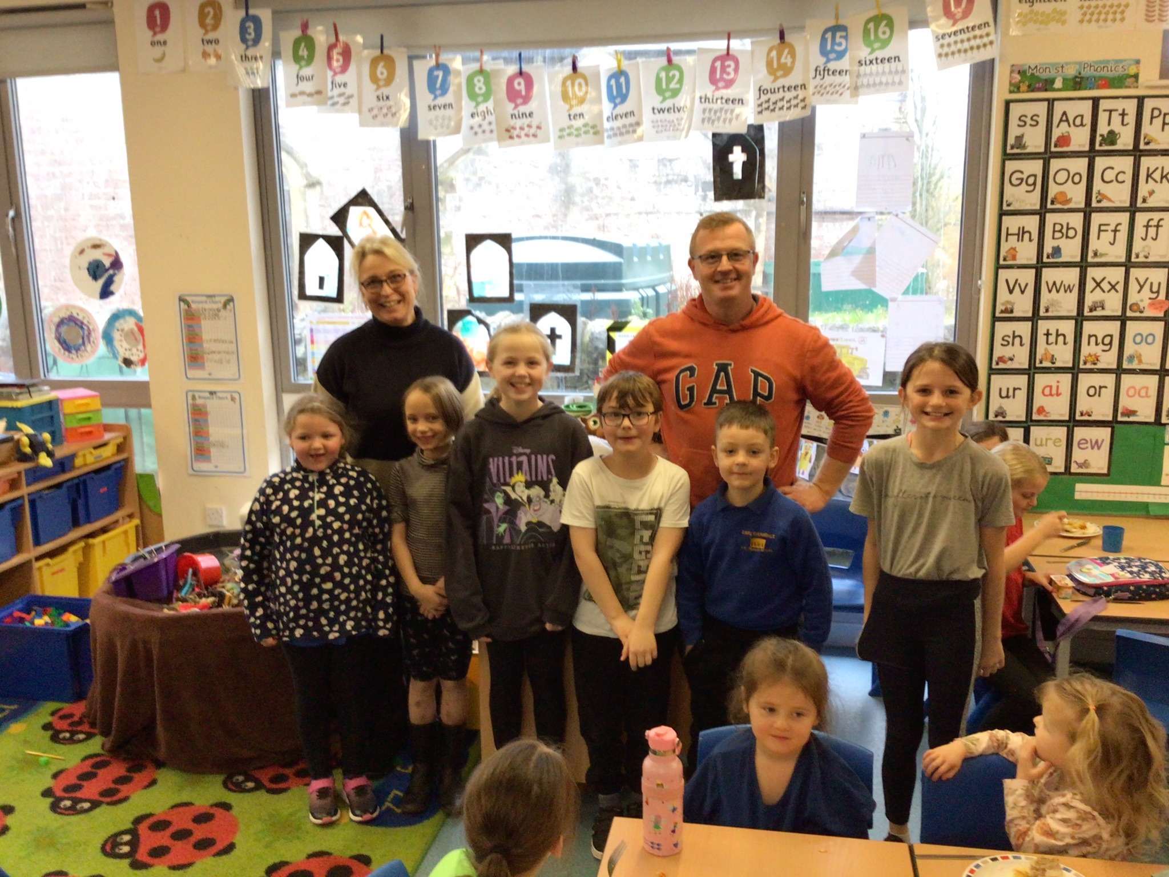
Watch this space…

